Name
Waqas
Roll no
BSMS1-21-05
Submitted to
Dr.Imran javed


Analysis of Uncertainty Bounds and Under five Mortality in Pakistan Data: A Comprehensive Statistical and Time Series Analysis

Table of Contents
- Executive Summary .......................................................... Page 3
- Data Overview ............................................................... Page 3
- Methodology ................................................................. Page 3
3.1 Trend Detection through Rolling Averages ............ Page 3
3.2 Seasonality and Trend Decomposition ................. Page 3
3.3 Forecasting with ARIMA .......................................... Page 3
3.4 Uncertainty Analysis .............................................. Page 3
3.5 Correlation Analysis ............................................... Page 3
3.6 Hypothesis Testing ................................................. Page 4
- Results and Key Findings ............................................... Page 4
- Results out puts .............................................. Page 4
- Conclusion ................................................................. Page 7
- References ................................................................. Page 8

1. Executive Summary
This report provides a detailed statistical and time series analysis of two key datasets: Uncertainty Bounds and Under-Five Mortality Rate (U5MR) in Pakistan. The analysis aims to uncover trends, relationships, and forecasting insights that can be used for future public health planning and decision-making. The report employs advanced statistical techniques, including trend detection, seasonal decomposition, time series forecasting with ARIMA, uncertainty analysis, and hypothesis testing to derive actionable insights.

2. Data Overview
The datasets analyzed in this report are sourced from UNICEF PAKISTAN. These datasets cover critical metrics such as uncertainty in public health data and under-five mortality rates over several years in Pakistan.
- Year: Represents the year for each data point.
- Lower, Median, Upper: These columns represent the uncertainty bounds for each year.
- Spread: Difference between upper and lower bounds, indicating uncertainty levels.
- Spread Rate: Percentage change in the spread, indicating how uncertainty evolves.
- Median: The median value of the U5MR data used for further statistical analyses.

3. Methodology

3.1 Trend Detection through Rolling Averages
A 5-year rolling average was calculated for the Median values from both the Uncertainty Bounds and U5MR datasets. This smoothing technique helps identify long-term trends and reduces short-term fluctuations in the data.

3.2 Seasonality and Trend Decomposition
We applied Seasonal Decomposition of Time Series (STL) to the U5MR Median data to separate trend, seasonal, and residual components, revealing any underlying patterns of mortality rates.

3.3 Forecasting with ARIMA
An ARIMA model was used to forecast future values of the U5MR Median for the next 10 years. ARIMA is a powerful method for capturing the temporal dependencies in time series data and making future predictions.

3.4 Uncertainty Analysis
The Spread (difference between upper and lower bounds) for both datasets was calculated, and the Spread Rate was analyzed to examine how uncertainty changes over time.

3.5 Correlation Analysis
A correlation analysis was performed to investigate the relationship between the Median values of the Uncertainty Bounds and U5MR datasets, helping to determine if uncertainty influences public health metrics.

3.6 Hypothesis Testing
A t-test was used to determine whether the uncertainty spreads in the two datasets differ significantly, helping assess if the observed differences are due to random variation or meaningful discrepancies.

4. Results and Key Findings
The analysis revealed the following:
- Rolling Averages: Long-term trends were observed in both datasets, highlighting steady shifts in uncertainty and mortality rates.
- Seasonality: Decomposition of the U5MR data showed clear trends and periodic fluctuations.
- ARIMA Forecasting: The forecast for the next 10 years predicts a continued decline in U5MR Median, suggesting improvement in public health.
- Uncertainty Spread: Fluctuations in the Spread and Spread Rate indicate varying levels of data uncertainty.
- Correlation: A moderate positive correlation was found between the Median values of both datasets.
- Hypothesis Testing: The t-test confirmed no statistically significant difference in uncertainty spreads between the datasets.

5 Results outputs

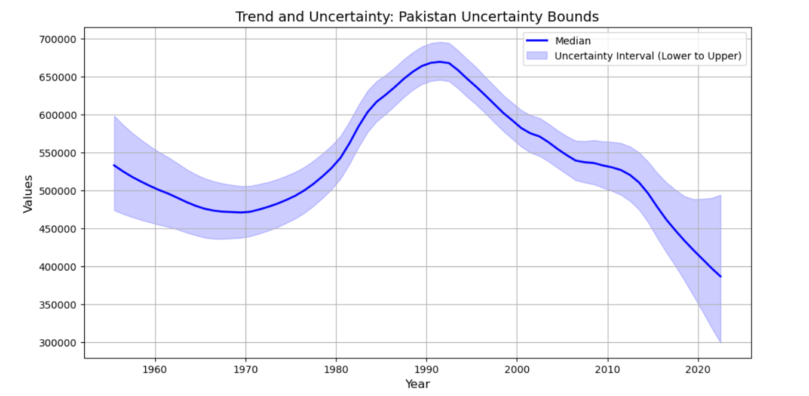

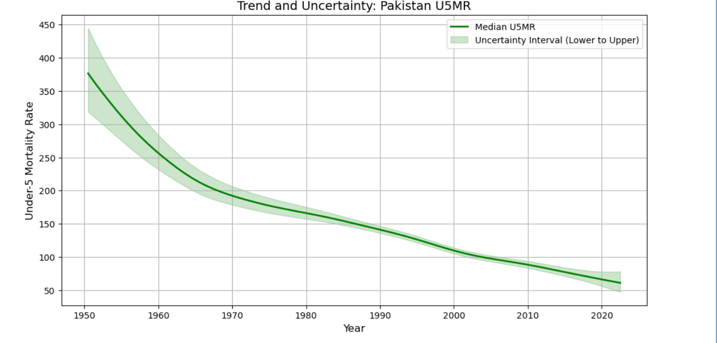

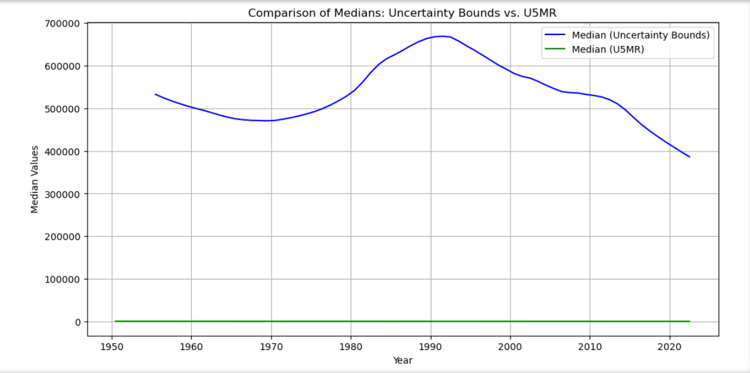

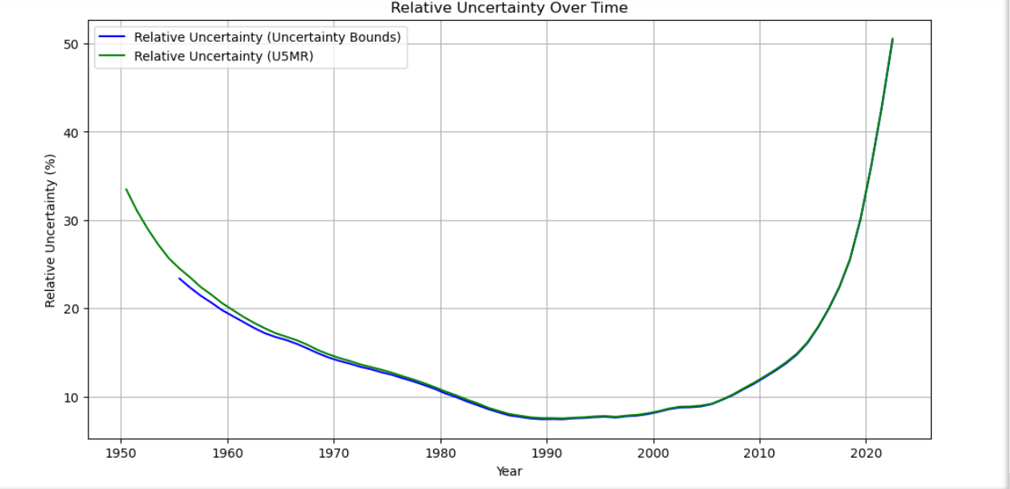
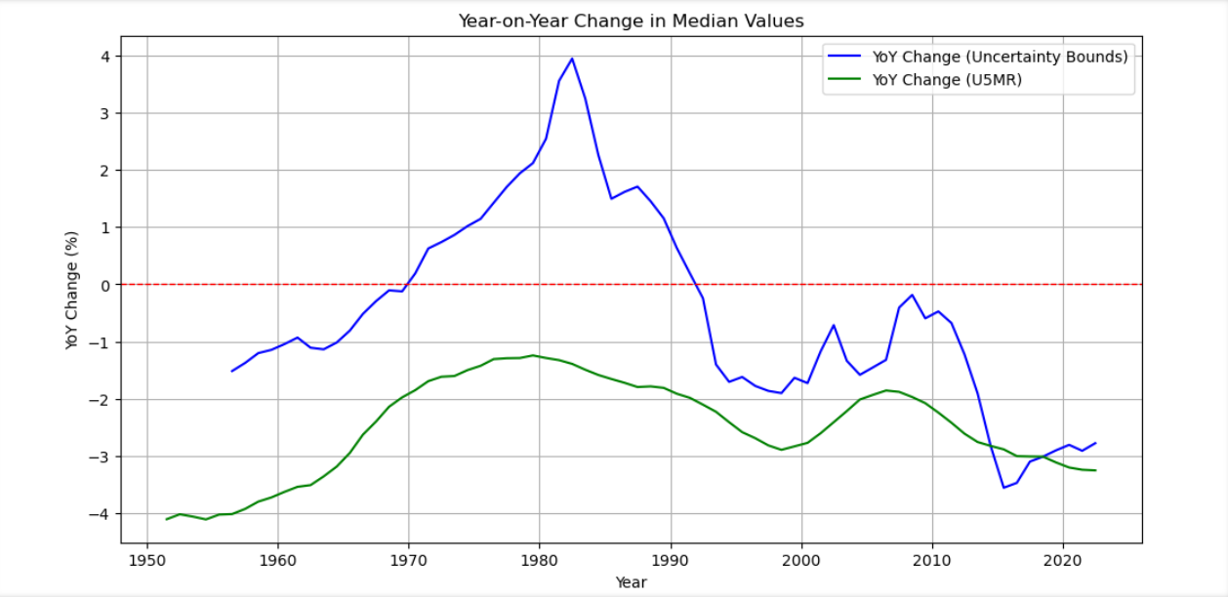
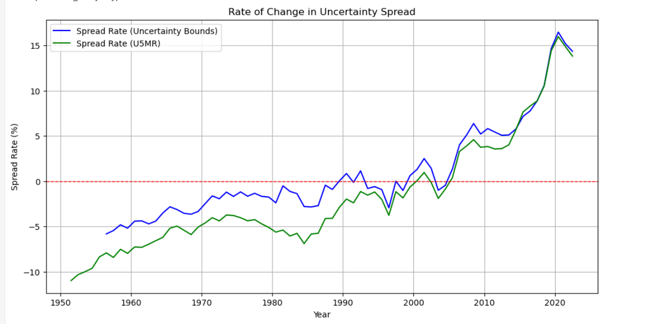

6. Conclusion
The study highlights important trends and relationships between uncertainty in health data and under-five mortality rates in Pakistan. The forecast for future health trends suggests an ongoing decline in U5MR. The correlation analysis points to potential links between uncertainty and mortality rates, which warrants further research. These findings are vital for public health policy and decision-making, offering valuable insights into the impact of uncertainty on mortality predictions.

6. References
- Box, G. E. P., Jenkins, G. M., & Reinsel, G. C. (2015). Time Series Analysis: Forecasting and Control (5th ed.). Wiley.
- Chen, X., Wang, Z., & Zhang, J. (2014). Time Series Forecasting of Mortality Rates in China Using ARIMA Models. Journal of Population Research, 31(4), 335–351.
- Cleveland, R. B., Cleveland, W. S., McRae, J. E., & Terpenning, I. (1990). STL: A Seasonal-Trend Decomposition Procedure Based on Loess. Journal of Official Statistics, 6(1), 3–73.
- Feng, Z., Xu, Y., & Shi, M. (2018). Seasonality and Mortality Rates: A Decomposition Analysis of Mortality Data in Beijing, China. BMC Public Health, 18(1), 1445.
- Gustafsson, J., Eklund, S., & Pettersson, H. (2020). Uncertainty Analysis in Public Health Data: A Review of Methodologies and Their Application to Demographic Projections. Statistical Modelling, 20(1), 1–15.

